To Whom It May Concern:
Disagree Wisely, Inc. is a Florida nonprofit corporation that has applied for federal 501(c)(3) charitable tax-exempt status with the Internal Revenue Service. We are currently working with Foundation Group to complete our IRS Form 1023 application, which is in process.
We have properly registered as a Foreign Business Entity with the Pennsylvania Department of State and are now completing our local tax registration requirements with the City of Pittsburgh.
While we do not yet have our IRS determination letter, we are registering as a "Charitable Non-Profit" with the City of Pittsburgh because:
- We are incorporated as a nonprofit corporation under Florida law (see attached Articles of Incorporation)
- We are properly registered to do business in Pennsylvania
- We are applying for 501(c)(3) charitable status with the IRS
- Our organizational purpose and activities qualify for charitable tax exemption
- We operate exclusively for charitable, educational, and research purposes
We expect to receive our IRS determination letter within the coming months.
Attached Documentation:
- Florida Articles of Incorporation
Please contact me at (412) 909-7608 or nick@swaybeta.ai if you need any additional information.
Sincerely,
Nicholas DiBella
Treasurer and Secretary, Disagree Wisely, Inc.
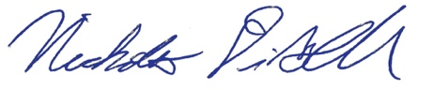
July 20, 2025

